**Dorinda Schmidtknecht: Mobilizing Financial and Business Management Solutions Globally**

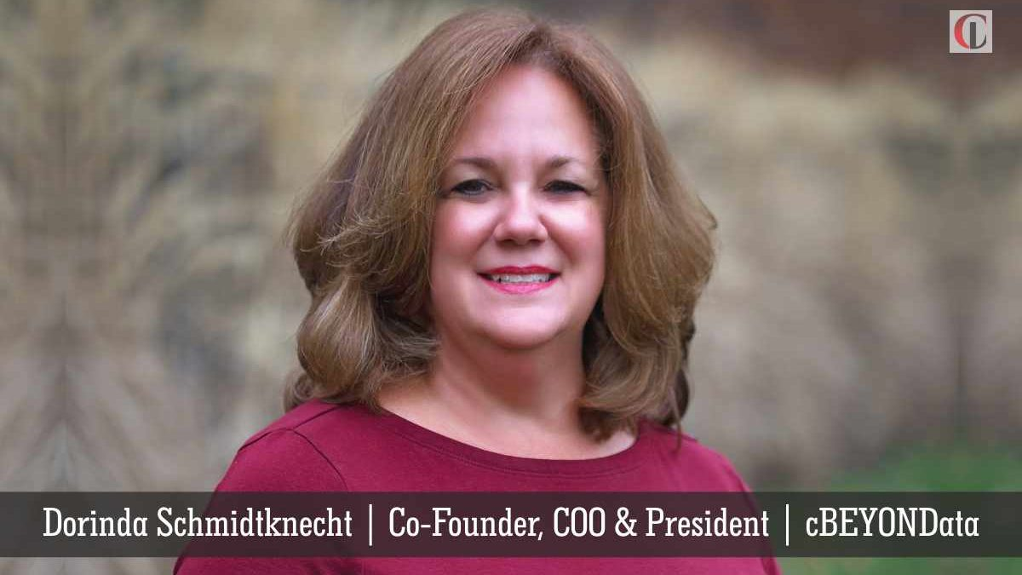

***Professionalism*** retains integrity and result oriented strategies that relatively exemplify the successful competency of an organization. **cBEYONData** has proved to be a reliable business services provider in the market. Co-founded by a prolific and all-encompassing leader, **[Dorinda Schmidtknecht,](http://ciolook.com/dorinda-schmidtknecht-mobilizing-financial-and-business-management-solutions-globally/)**[the](http://ciolook.com/dorinda-schmidtknecht-mobilizing-financial-and-business-management-solutions-globally/)**[COO](http://ciolook.com/dorinda-schmidtknecht-mobilizing-financial-and-business-management-solutions-globally/)**[and**President,**](http://ciolook.com/dorinda-schmidtknecht-mobilizing-financial-and-business-management-solutions-globally/)the organization has ardently procured a steady pace towards success. Her unique approach and distinctive ideologies have contributed in the evolution of financial management sectors. CIO Look admires such leaders and considers it as an opportunity to feature determined personalities in this edition.

*Following is Dorinda’s story and her endeavors on building an empire in financial and management solutions, in her own words:*

The establishment of the company came about when Dave, my husband and co-founder, and I decided that after working for many people throughout the years, we could do a better job by building a company based on ethical foundations and focuses on employees while ensuring we serve our customers with unique and cutting-edge solutions, all while making a profit and having a financially sound company.

Read more:[Mobilizing Financial and Business Management Solutions Globally](http://ciolook.com/dorinda-schmidtknecht-mobilizing-financial-and-business-management-solutions-globally/)